Assignment Overview
The objective of this design is to efficiently store data and have correct data without redundancy. It can analyze high volume of data . The source data set contains NSE – Future and Options Data which consists of trading data only for multiple future and options. To avoid duplication the schema is designed in 3NF form .
I have made designed 3 tables out of the available raw data present .
  - Instruments
  - Contracts
  - Trades

- Instuments Table :
This table stores high level instruments value/data
Symbol (eg : Nifty , BankNifty ) Instrument Type (eg : Futidx,Optidk) , Exchange Name (eg : NSE for current dataset )
Idea : Separating instruments helps to avoid repeating symbol and instrument type and also supports future multi-exchange ingestion

- Contracts Table :
This table stores unique feature of F & O contracts :
Instrument , Expiry Date , Strike Price
A contract cab be uniquely identified by expiry and strike as these values don’t change daily and need not be in trades table

- Trades Table :
This table stores daily market activity
Open, High, Low, Close, Settle Price , etc.
This is the highest-volume table and contains time-series data used for all analytical queries.
Keeping this as a separate fact table improves performance and supports efficient aggregation queries.

ER DIAGRAM
- Relationship Flow
The logical relationships between tables are:
- One Instrument can have many Contracts
- One Contract can have many Trades

- This represents a clear hierarchical structure:
INSTRUMENT → CONTRACT → TRADE

- Cardinality
- INSTRUMENTS (1) → CONTRACTS (Many)
- CONTRACTS (1) → TRADES (Many)

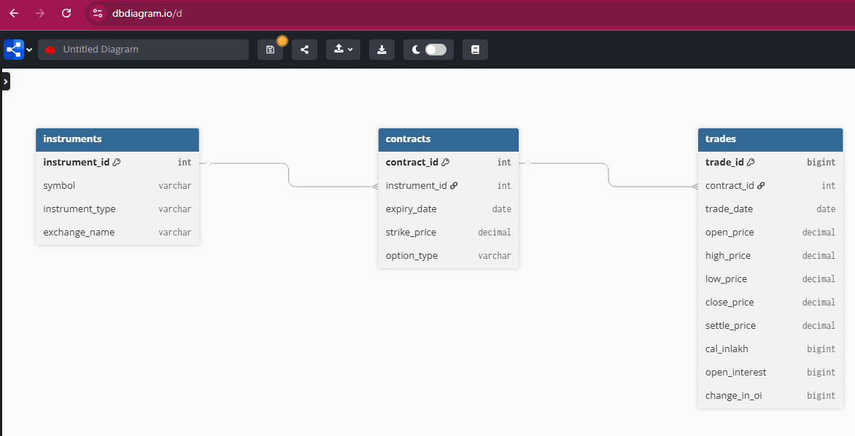

SNOWFLAKE OPERATIONS & QUERIES
I have used snowflake as a platform for loading data and doing further transformations and queries.
Steps to Load Data in snowflake .
- Downloaded the given data set from Kaggle.com
- Uploaded the CSV file into snowflake with the help of – Direct CSV upload option. (we can also create stage and upload the file.)
- Created the DB and Schema for the Table to store as Raw Data
ASSIGNMENT(DB) FUTURE_OPTIONS(Schema) (FNO_RAW(Table)
- I have 1 table as RAW_FnO which consists of the same Data undisturbed.
- I have created 4 different tables and performed the queries on them

Queries
- Top Symbols by open interest change
- This query shows the buildup against symbols of NSE for highest Open-Interest change
select
i.symbol,
sum(t.change_in_oi) as total_oi_change
from trades t
inner join contracts c
on t.contract_id = c.contract_id
inner join instrumentsi
on c.instrument_id = i.instrument_id
group by i.symbol
order by total_oi_change desc
limit 10;

Output :
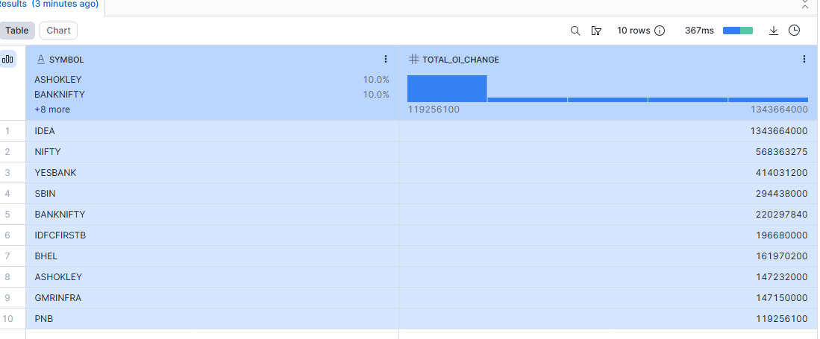

- 7 day rolling volatility for NFTY options
- A rolling standard deviation of close prices helps measure short-term market uncertainty rather than using a single-day snapshot.
select
t.trade_date,
stddev(t.close_price)
over (order by t.trade_date
rows between 6 preceding and current row) as rolling_7d_volatility
from trades t
join contracts c
on t.contract_id = c.contract_id
join instruments i
on c.instrument_id = i.instrument_id
where i.symbol = 'nifty'
and i.instrument_type like 'opt%'

Output :

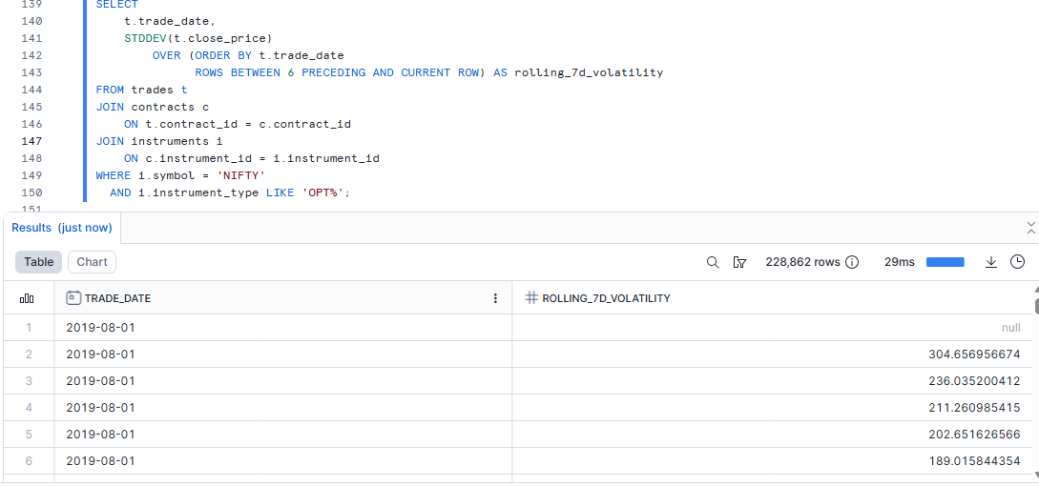

- Cross exchange price comparison
- This query tells us how settlement prices of diff exchanges are compared
select
i.exchange_name,
avg(t.settle_price) as avg_settle_price
from trades t
inner join contracts c
on t.contract_id = c.contract_id
inner join instruments i
on c.instrument_id = i.instrument_id
where i.symbol in ('mindtree', 'pidilitind')
group by i.exchange_name;

Output :
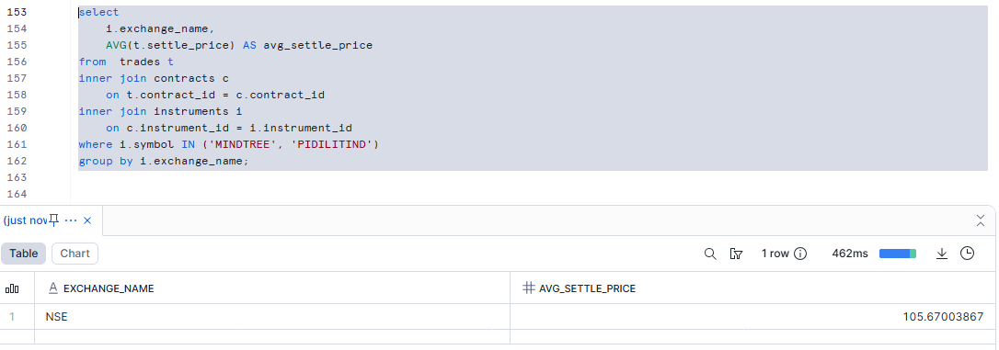

- Option change summary by expiry and strike
- Tells us how trading volume is distributed across strikes and options
select
c.expiry_date,
c.strike_price,
sum(t.val_inlakh) as total_val
from trades t
join contracts c
on t.contract_id = c.contract_id
join instruments i
on c.instrument_id = i.instrument_id
where i.symbol = 'nifty'
and i.instrument_type like 'opt%'
group by c.expiry_date, c.strike_price
order by c.expiry_date, c.strike_price;

Output :
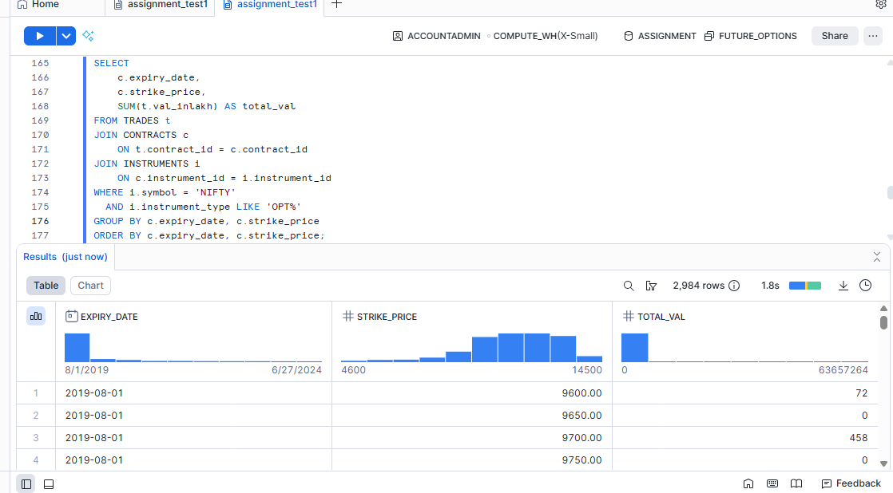

- Max vol in specified date range
- Recent volume spikes indicate increased interest and potential price movement.
select
i.symbol,
max(t.val_inlakh) as max_value
from trades t
join contracts c
on t.contract_id = c.contract_id
join instruments i
on c.instrument_id = i.instrument_id
where t.trade_date>= '2019-10-18'
group by i.symbol
order by max_value desc;

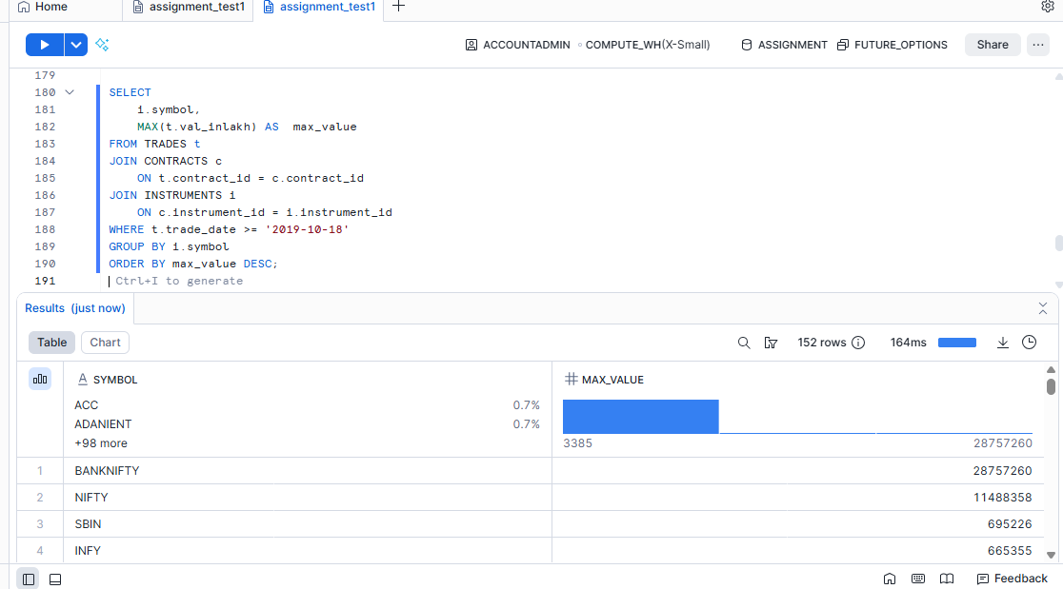

DDL and Table Creation and Loading
create or replace database assignment;
create or replace schema assignment.future_options;
create or replace table future_options.fno_raw (
id bigint,
instrument string,
symbol string,
expiry_dt date,
strike_pr number(10,2),
option_typ string,
open_price number(10,2),
high_price number(10,2),
low_price number(10,2),
close_price number(10,2),
settle_pr number(10,2),
contracts number(10,2),
val_inlakh number,
open_int number,
chg_in_oi number,
trade_timestamp timestamp
);
select * from future_options.fno_raw limit 100 ;
create or replace table future_options.exchange (
exchange_id integer autoincrement ,
exchange_name string
) ;
insert into future_options.exchange (exchange_name) values ('nse'),('bse'),('mcx') ;
select * from exchange ;
create or replace table future_options.instruments (
instrument_id integer autoincrement,
symbol string,
instrument_type string,
exchange_name string
);
insert into instruments (symbol, instrument_type,exchange_name)
select distinct symbol, instrument,'nse' from fno_raw;
select * from instruments ;
create or replace table contracts (
contract_id integer autoincrement,
instrument_id integer,
expiry_date date,
strike_price number(10,2),
option_type string
) ;
insert into contracts (
instrument_id,
expiry_date,
strike_price,
option_type
)
select distinct
i.instrument_id,
r.expiry_dt,
r.strike_pr,
r.option_typ
from fno_raw r
join instruments i
on r.symbol = i.symbol
and r.instrument = i.instrument_type;
select * from contracts order by contract_id asc limit 100 ;
create or replace table trades (
trade_id bigint autoincrement,
contract_id integer,
trade_date date,
open_price number(10,2),
high_price number(10,2),
low_price number(10,2),
close_price number(10,2),
settle_price number(10,2),
val_inlakh number,
open_interest number,
change_in_oi number
);
insert into trades (
contract_id,
trade_date,
open_price,
high_price,
low_price,
close_price,
settle_price,
val_inlakh,
open_interest,
change_in_oi
)
select
c.contract_id,
cast(r.trade_timestamp as date) as trade_date,
r.open_price,
r.high_price,
r.low_price,
r.close_price,
r.settle_pr,
r.val_inlakh,
r.open_int,
r.chg_in_oi
from fno_raw r
join instruments i
on r.symbol = i.symbol
and r.instrument = i.instrument_type
join contracts c
on c.instrument_id = i.instrument_id
and c.expiry_date = r.expiry_dt
and nvl(c.strike_price, 0) = nvl(r.strike_pr, 0)
and nvl(c.option_type, 'xx') = nvl(r.option_typ, 'xx');

